VLSI Design Internship – Task 2 Report
Introduction to Verilog HDL and RTL Design of Basic Combinational Circuits

Submitted By
Name: Varsha Rathod
Internship: VLSI Design Internship
Organization: Main Crafts Technology

Objective
The objective of this task is to learn the fundamentals of Verilog Hardware Description Language (HDL) and implement basic combinational circuits using RTL (Register Transfer Level) modeling. The task also aims to develop skills in writing Verilog testbenches, simulating digital circuits, and analyzing waveform outputs.

Introduction
Digital systems form the foundation of modern electronic devices, including computers, smartphones, communication systems, automobiles, medical equipment, and embedded systems. These systems are built using digital logic circuits that process binary information represented by logic levels 0 and 1. To design and verify such circuits efficiently, Hardware Description Languages (HDLs) are widely used in the VLSI (Very Large Scale Integration) industry.
Verilog Hardware Description Language (Verilog HDL) is one of the most popular HDLs used for modeling, designing, simulating, and verifying digital circuits. It allows designers to describe the behavior and structure of digital hardware using programming-like syntax before the actual hardware is manufactured. This helps identify and correct design errors early in the development process, reducing both development time and cost.
Register Transfer Level (RTL) is a design abstraction used to describe how data moves between registers and how logical operations are performed on that data. RTL modeling is a fundamental step in the VLSI design flow because it provides a clear representation of digital circuit functionality and serves as the basis for synthesis into hardware.
In this task, Verilog HDL was used to implement basic combinational circuits, including logic gates (AND, OR, NOT, NAND, NOR, and XOR), a Half Adder, and a Full Adder. Each circuit was designed using RTL modeling techniques and verified by writing appropriate testbenches. Simulations were performed to validate the functionality of each design, and waveform analysis was carried out to ensure that the outputs matched the expected truth tables for all possible input combinations.

1. AND Gate
Objective
To implement the logical AND operation using Verilog HDL.
Truth Table
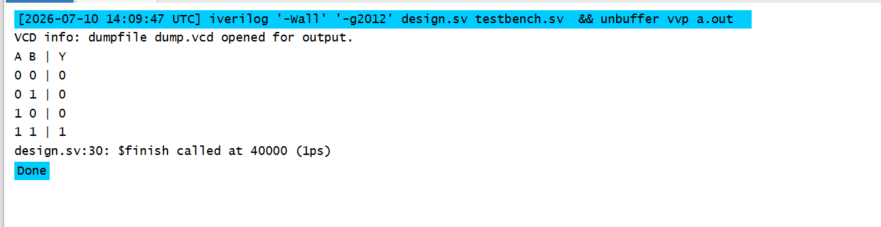
Verilog Design
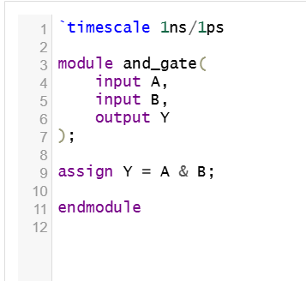
Testbench
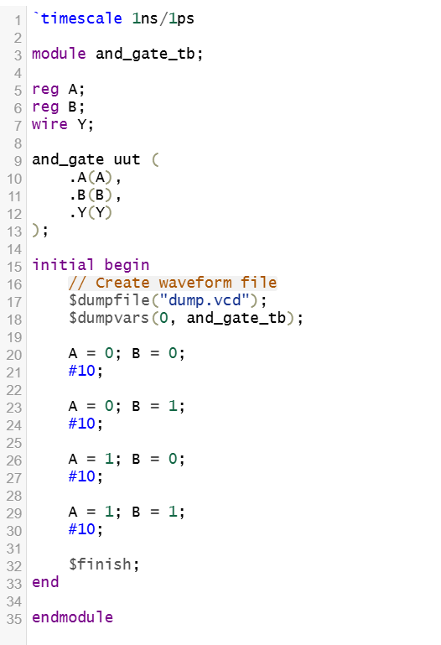
Simulation Result
The simulation verified that the output becomes HIGH only when both inputs are HIGH.
Waveform
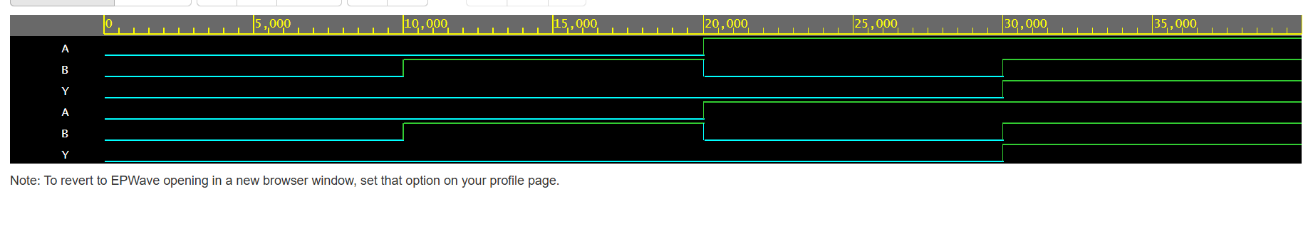

2. OR Gate
Objective
To implement the logical OR operation using Verilog HDL.
Truth Table
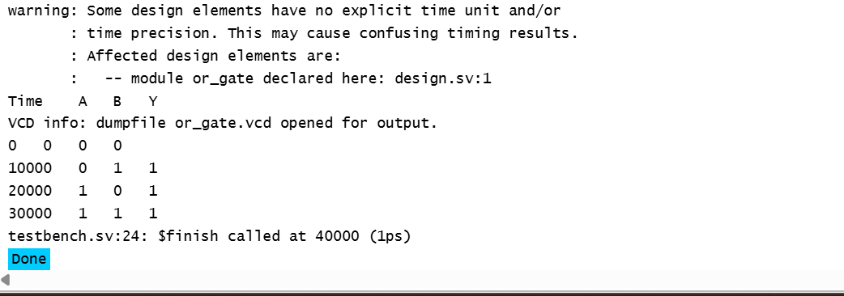
Verilog Design
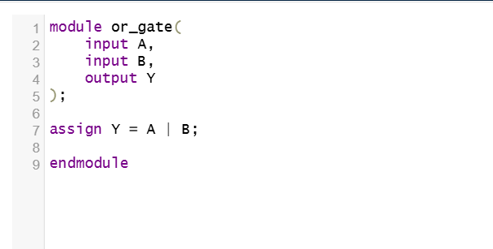
Testbench
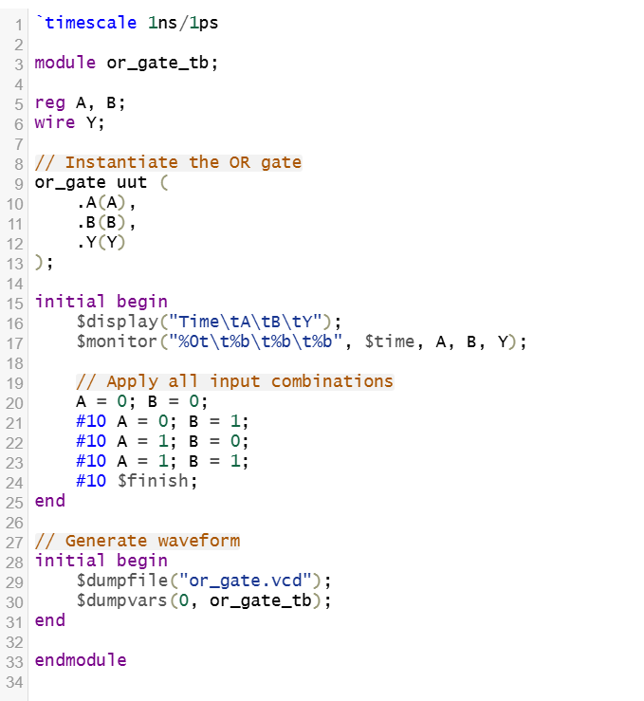
Simulation Result
The output becomes HIGH whenever at least one input is HIGH.
Waveform
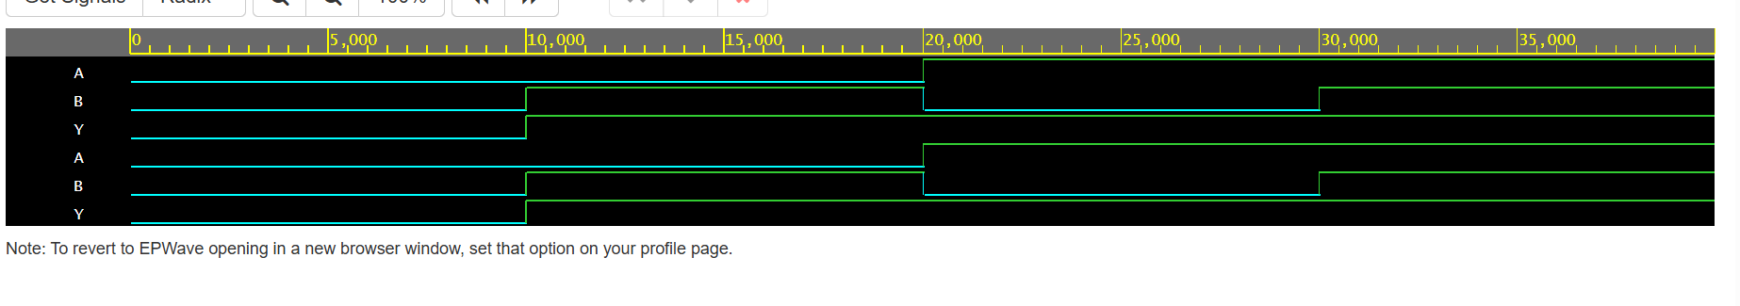

3. NOT Gate
Objective
To implement the logical NOT operation.
Truth Table
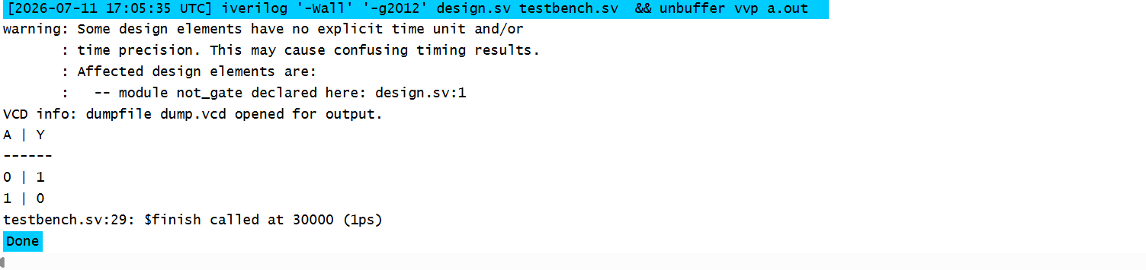
Verilog Design
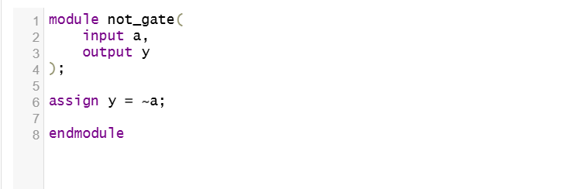
Testbench
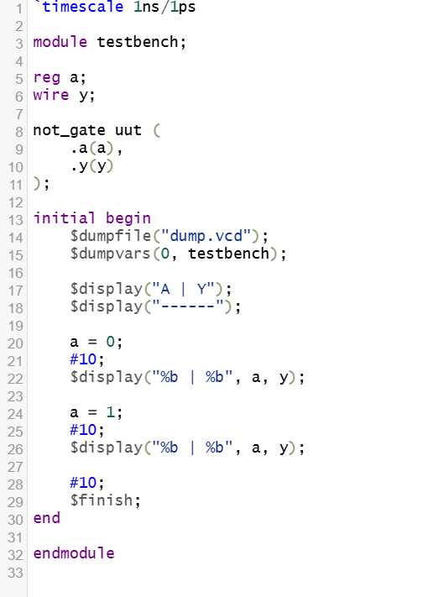
Simulation Result
The output is the complement of the input.
Waveform
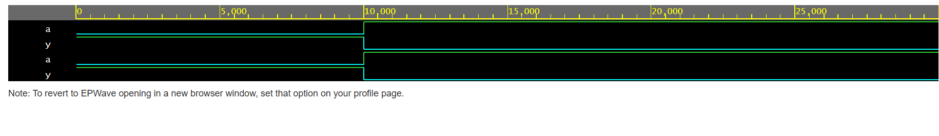

4. NAND Gate
Objective
To implement the logical NAND operation.
Truth Table
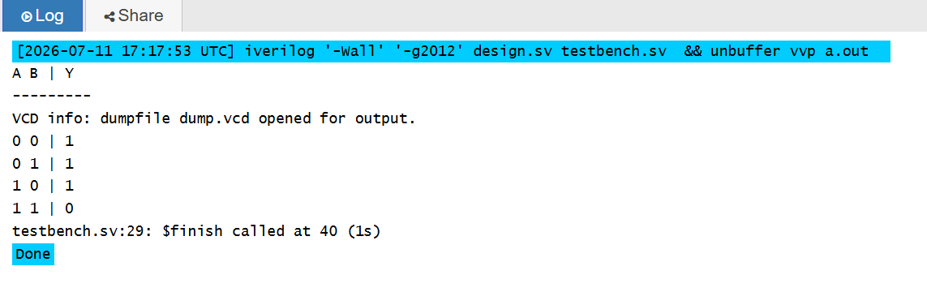
Verilog Design
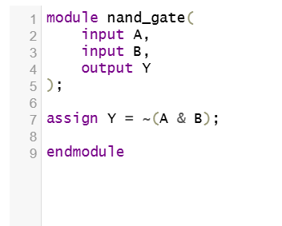
Testbench
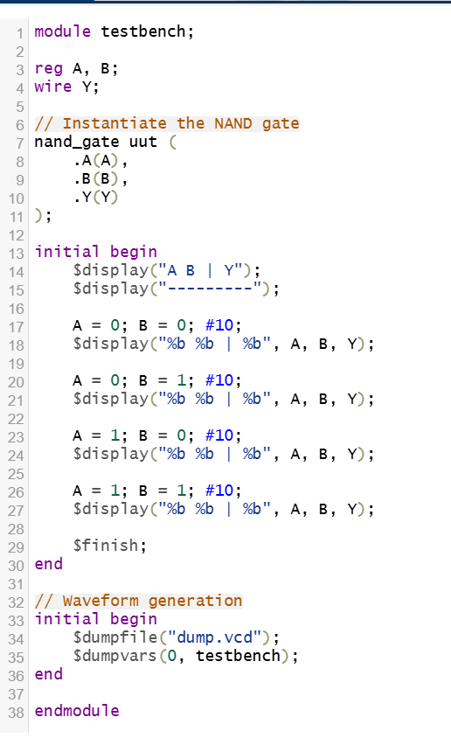
Simulation Result
The output becomes LOW only when both inputs are HIGH.
Waveform
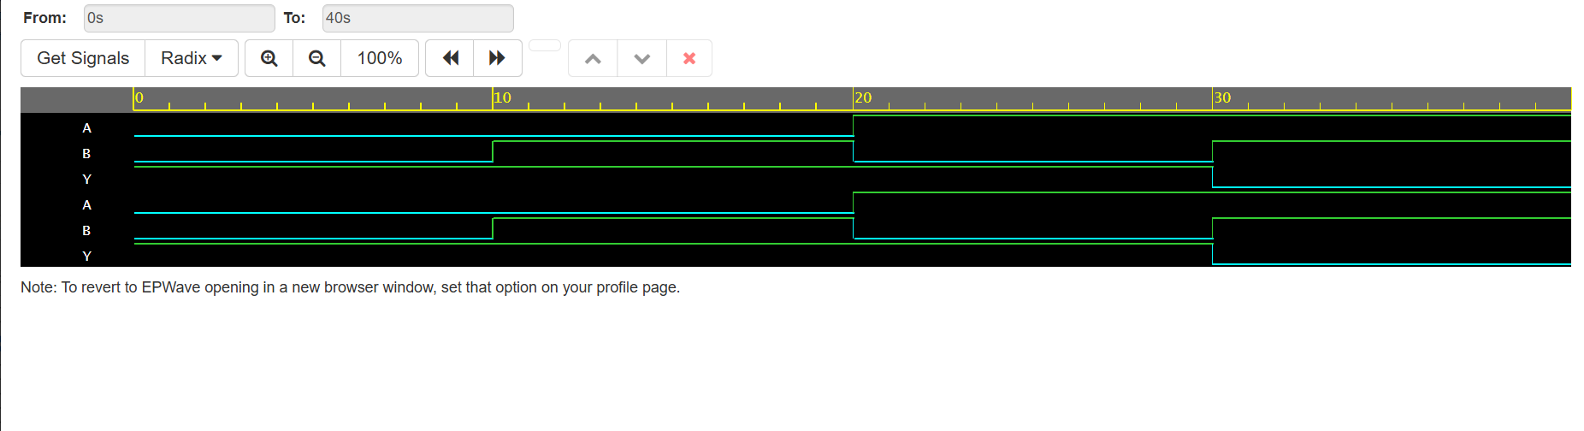

5. NOR Gate
Objective
To implement the logical NOR operation.
Truth Table
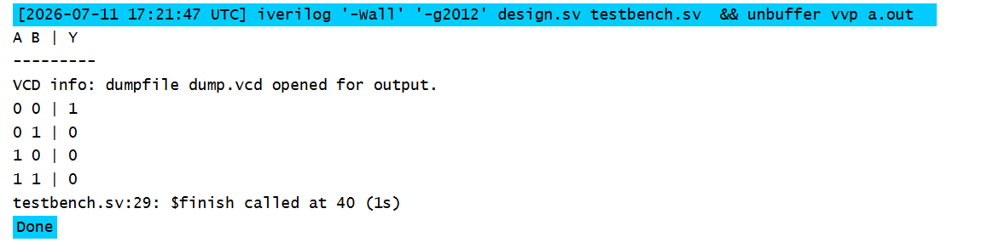
Verilog Design
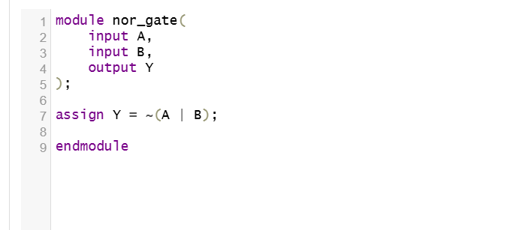
Testbench
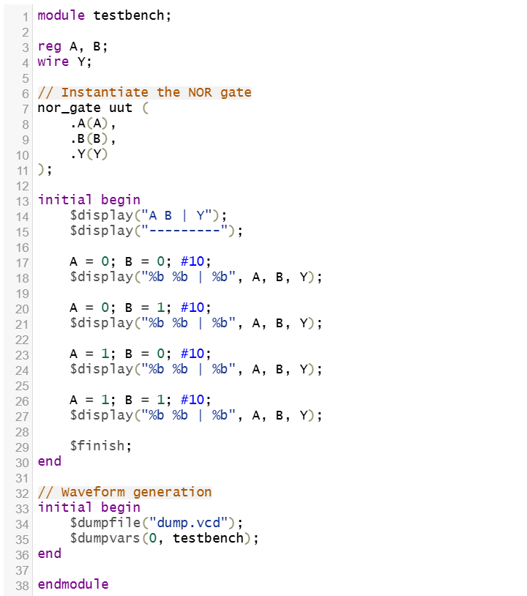
Simulation Result
The output becomes HIGH only when both inputs are LOW.
Waveform
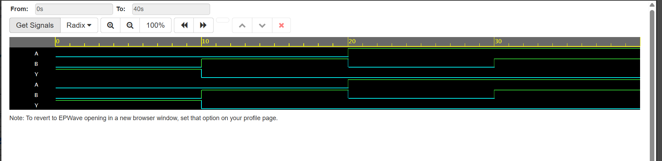

6. XOR Gate
Objective
To implement the Exclusive OR operation.
Truth Table
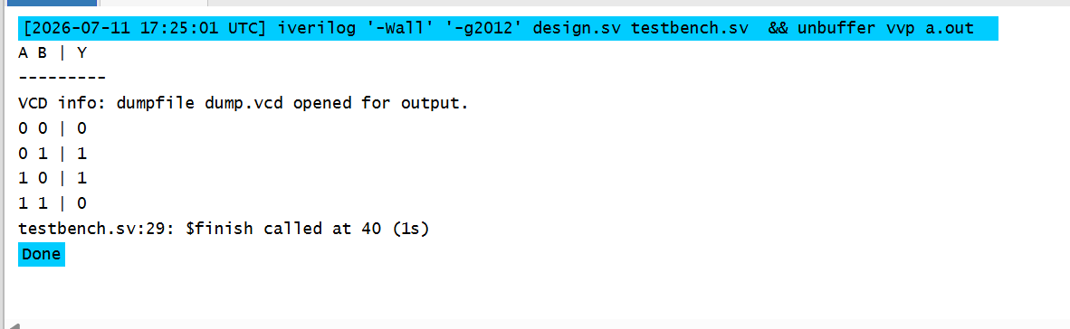
Verilog Design
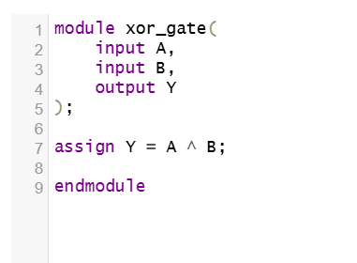
Testbench
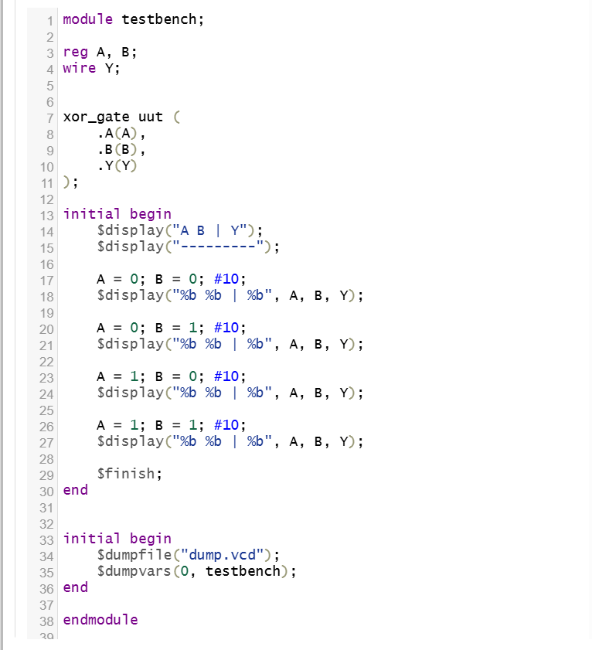
Simulation Result
The output becomes HIGH when both inputs are different.
Waveform
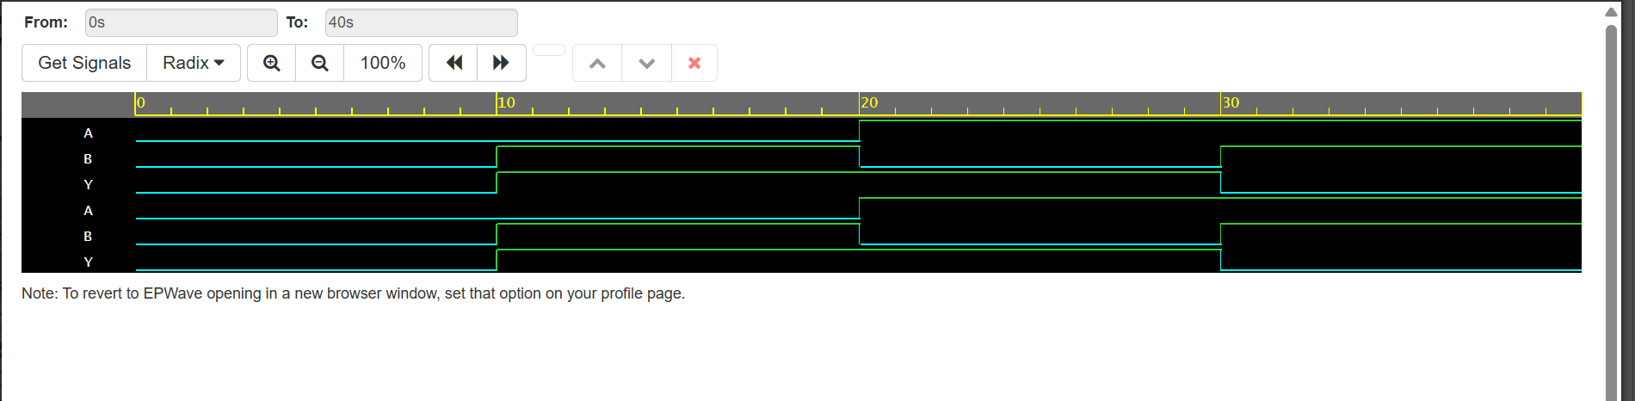

7. Half Adder
Objective
To implement a Half Adder using Verilog HDL.
Truth Table
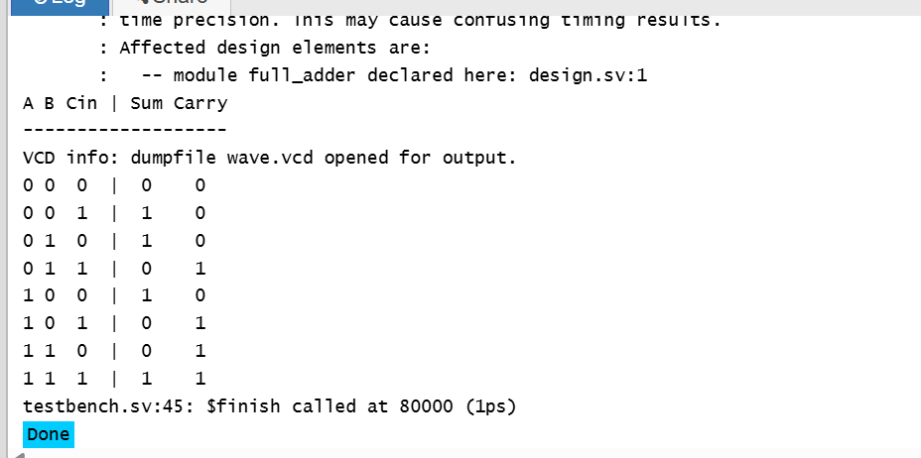
Verilog Design
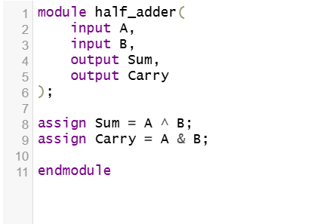
Testbench
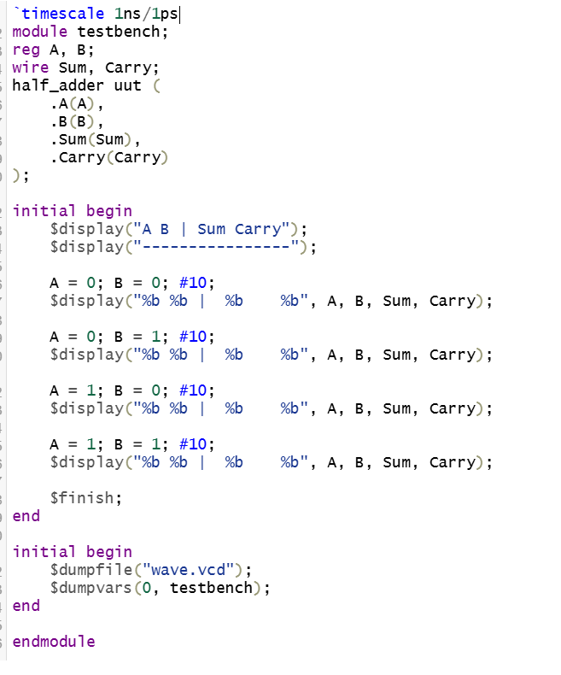
Simulation Result
The Half Adder correctly generates the Sum and Carry outputs for all possible input combinations.
Waveform
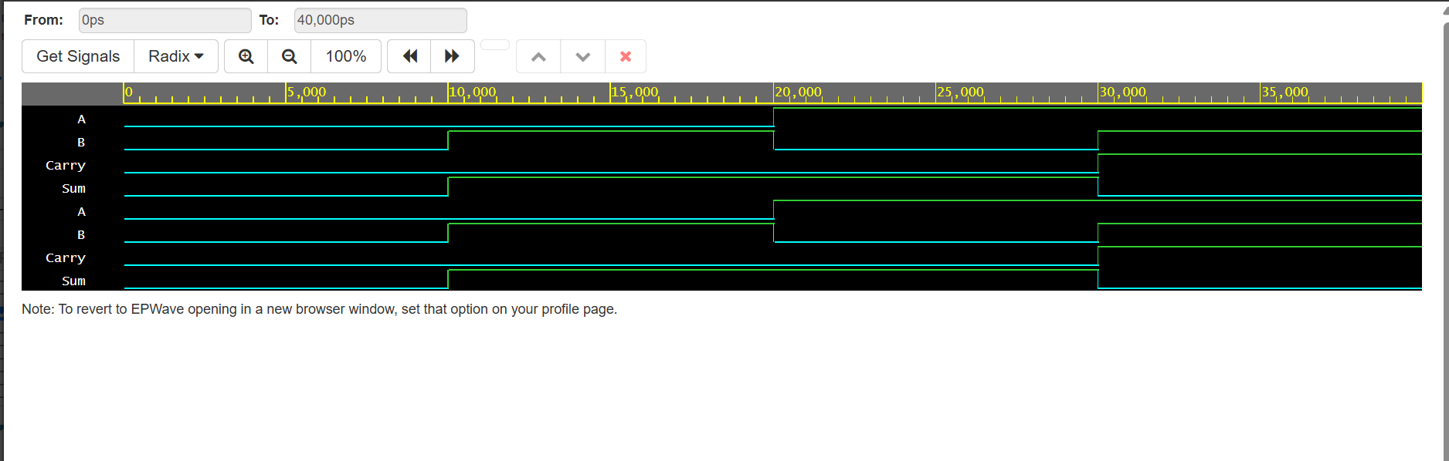

8. Full Adder
Objective
To implement a Full Adder using Verilog HDL.
Truth Table

Verilog Design
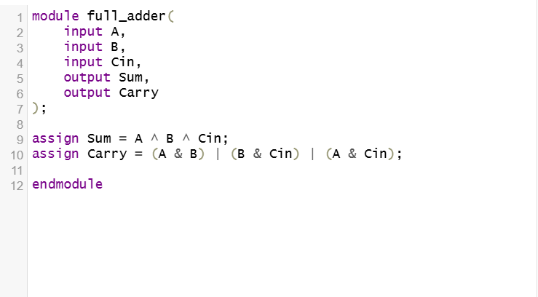
Testbench
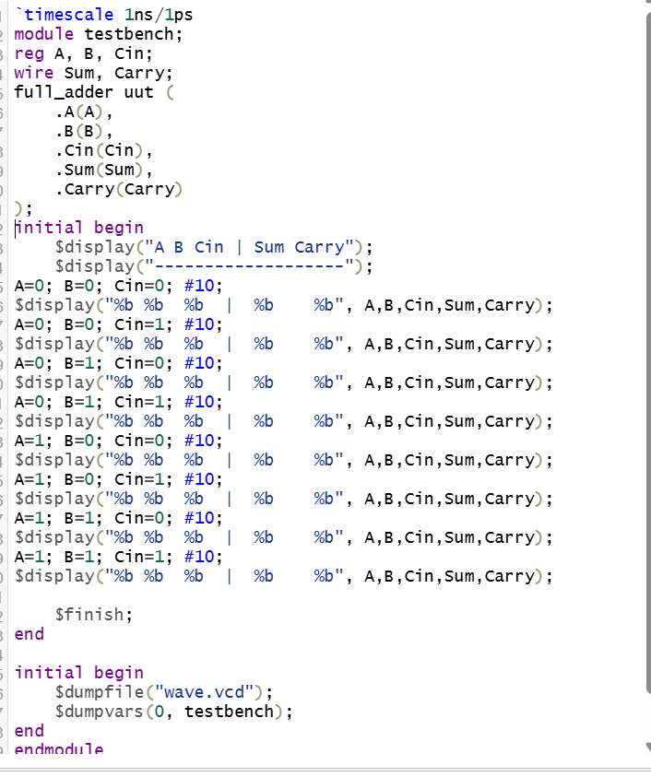
Simulation Result
The Full Adder correctly generates the Sum and Carry outputs for every combination of A, B, and Carry-In.
Waveform
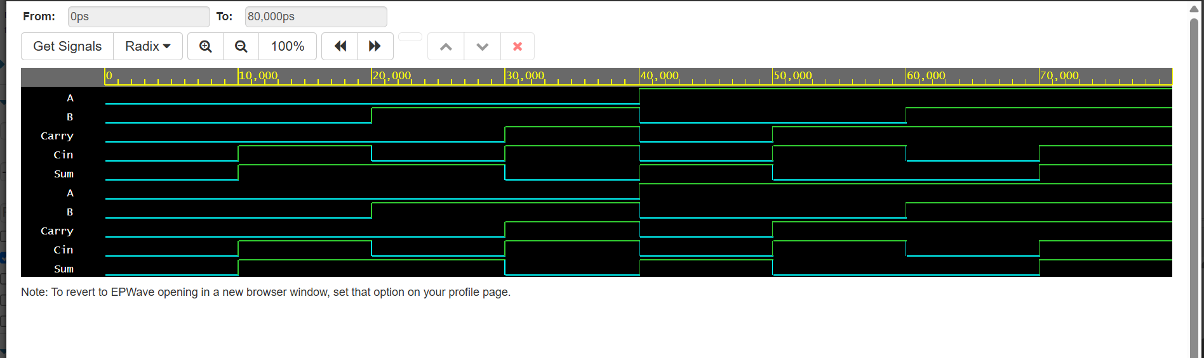

Simulation Results
All implemented circuits were simulated successfully using Verilog simulation tools. The generated outputs matched the expected truth tables, confirming the correctness of the Verilog modules and testbenches. Waveform analysis also verified the logical behavior of each circuit.

Learning Outcomes
Through this task, I learned:
- Basics of Verilog HDL
- Verilog module structure
- RTL modeling
- Combinational circuit implementation
- Continuous assignment using assign
- Writing Verilog testbenches
- Running Verilog simulations
- Waveform analysis using GTKWave
- Organizing and documenting projects using GitHub

Conclusion
This task provided practical experience in designing and verifying basic combinational circuits using Verilog HDL. By implementing logic gates, Half Adder, and Full Adder circuits, writing corresponding testbenches, and analyzing simulation waveforms, I gained a solid understanding of RTL design and the digital design workflow. This task strengthened my foundation in hardware description languages and prepared me for more advanced VLSI design concepts.

